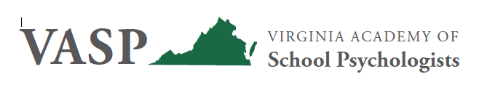
VASP Fall Conference WEBINAR Preliminary Program
October 30, 2020
9:00 a.m. – 2:30 p.m.
Presentation Topics:
Social Justice with Charles Barrett, Ph.D.
Ethics with Eric Mesmer, Ph.D.; Melinda Cruz, Ph.D.; Emily Dove, Ed.S.; and Jennifer Mabry, Ed.D.

VASP Business Meeting and Lunch Break
Trauma and Covid-19 with Terri Sisson, Ed.S.
Session descriptions, including learning objectives, will be included in the full program. The webinar will be live on Zoom, but will also be recorded and all registrants will receive the recording via email.
Participants will earn 4.5 hours of NASP Approved credit.
Fees:
VASP Members: $45
Non Members: $75
VASP Student Members: $25
For questions regarding payment of fees, please contact VASP Treasurer Tom Byrnes at thomas.byrnes@portsk12.com.
Registration:
Register online at www.vaspweb.org – ensure that your email is correct as we will be emailing the Zoom link to you prior to the webinar. Registration is OPEN – Scroll down to Upcoming Events and click the link for the Fall Webinar Conference

