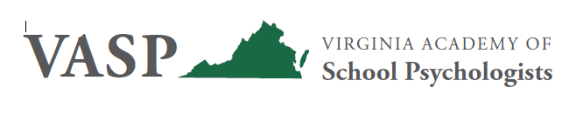

The Virginia Academy of School Psychologists (VASP) stands together with all people of our communities in heartbreak at the recent deaths of George Floyd, Breonna Taylor, Ahmaud Arbery, and the many other Black men and women who have lost their lives or suffered due to systemic racism. In our role, we are poised to promote equity, education, and positive steps for all. We know that children and families are suffering and we wish to offer support and healing.
VASP acknowledges that anti-racism is uncomfortable, lifelong work that needs to begin in earnest. It is important to acknowledge the trauma caused by racial injustice. It is also equally, if not more important, to be educated on White privilege. As school psychologists, we are responsible for dismantling systemic racism and modeling anti-racism for others. This work begins with self-assessment of implicit biases, skill development, and willingness to engage in courageous conversations and take action. VASP leadership remains committed to doing this hard work and reaffirms our core values of: Integrity, Continuous Improvement, Student Centered, Advocacy, Collaborative Relationships, Diversity, and Visionary Leadership.
In sum, VASP promotes equity for all in the spirit of peace and acceptance. School psychologists apply expertise in mental health, learning, and behavior, to help children and youth succeed academically, socially, behaviorally, and emotionally. We partner with families, teachers, school administrators, and other professionals to create safe, healthy, and supportive learning environments that strengthen connections between home, school, and the community (NASP, 2020). This responsibility belongs to all, especially those who experience the benefits of privilege. We can and must do better through our words and actions. Our children are depending on it.

